# 

**Merced MLRP Special Funding Opportunity**

## Why This Targeted Solicitation?

Following the project review process for applications submitted to the Merced Multibenefit Land Repurposing Program (MLRP) through [the RFP](https://www.mercedmlrp.org/funding-opportunities) that was released on November 15, 2024 and closed on March 14, 2025, the MSGSA Project Selection Committees identified a critical gap: a need for projects that directly benefit disadvantaged communities in the Merced Subbasin, which is a requirement of the MLRP. To address this, the Merced MLRP has reserved **$1.2 million** specifically for a project (or projects) that provide meaningful community benefits while supporting our groundwater sustainability goals.

## What We're Looking For:

Projects that:

* Convert irrigated agricultural land to less water-intensive uses, and
* Provide **direct, tangible, and meaningful benefits** to disadvantaged communities[1], and when possible, are co-created with relevant communities, and
* Can be fully implemented by March 30, 2027

## Priority Project Types:

* Projects improving drinking water supply and security for disadvantaged communities
* Projects creating green spaces, recreation areas, or other community assets
* Projects providing economic opportunities or workforce benefits
* Projects reducing environmental hazards (air quality, flood risk, etc.) in disadvantaged communities

## Priority Geographies:

* Projects with closer proximity to urban areas in the Merced Subbasin are likely to provide more substantial benefits to disadvantaged communities. Please see Figure 1 on page 3 for a map of Disadvantaged Communities and Domestic Well Density.

## Who Can Apply?

* Landowners
* Public agencies and local government agencies
* Nonprofit organizations
* California Native American Tribes
* Groundwater Sustainability Agencies in the Merced Subbasin

## Need Help? We're Here to Support You!

**Free technical assistance** is available to help you create a competitive application.

**Contact:** info@mercedmlrp.org | [www.mercedmlrp.org](http://www.mercedmlrp.org)

## Summary

This is a Request for Projects (RFP) and Project Application for the Merced Multibenefit Land Repurposing Program (MLRP). Projects submitted through this program must provide groundwater benefits by converting irrigated agricultural land to less water-intensive use(s) and must provide meaningful disadvantaged community benefits. Projects may provide additional benefits to wildlife habitat, flood control, and renewable energy transitions, among others.

If you are interested in submitting a project application but need assistance with the development of your project idea and/or the application, please fill out [this form](https://docs.google.com/forms/d/1upo6jqGFRPuqBoaSkE00ogx6gAhhB0nnVf7i_v3IzdQ/edit) or contact [info@mercedmlrp.org](mailto:info@mercedmlrp.org) with any questions.

*Para ver este aviso en español, por favor visite* [*www.mercedmlrp.org*](https://www.mercedmlrp.org/funding-opportunities)*. Si está interesado en presentar una solicitud de proyecto y le gustaría discutir su idea de proyecto y/o necesita asistencia con la solicitud, por favor consulte* [*este enlace*](https://docs.google.com/forms/d/e/1FAIpQLSehU3yx9aLuNL4C0HqDHNIwSqQq3PZBNbMsOqygC0LCHseqPg/viewform?usp=pp_url).

## MLRP Background

The Merced Subbasin Groundwater Sustainability Agency (GSA) and regional partners received a block grant to support land repurposing in the Merced Subbasin from the California Department of Conservation’s MLRP, which aims to reduce reliance on groundwater while providing community health, economic well-being, water supply, and other environmental benefits. This program provides an opportunity for farmers to develop alternative strategies for their irrigated lands while managing the impacts of groundwater constraints.

The MLRP is designed to support California communities that are navigating changes driven by historical unsustainable water use that led to the Sustainable Groundwater Management Act (SGMA), which sets a 2040/2042 target for transition to sustainable groundwater use. Experts estimate the water used to irrigate 500,000 to 1,000,000 acres of farmland in the San Joaquin Valley alone needs to be conserved. To achieve this, land will be left idle, retired, or repurposed to help balance groundwater supply and demand. When improperly managed, idle fields can emit dust and worsen air quality; host weeds and pests; and adversely impact agricultural economies, rural communities, and ecosystems.[2] Multibenefit Land Repurposing is a beneficial alternative that aims to reduce potential negative impacts and invest in solutions that provide benefits to both the environment and surrounding communities.

## 

## Geographic Boundary

Merced MLRP projects must be located in the Merced Subbasin. The Merced Subbasin is situated in Merced County, including the incorporated cities of Merced, Atwater, and Livingston, as well as urban communities including University Community, Franklin/Beachwood, Castle, Winton, El Nido, Stevinson, Cressey, Le Grand, and Planada. See Figure 1 below for more information on disadvantaged communities in the subbasin.

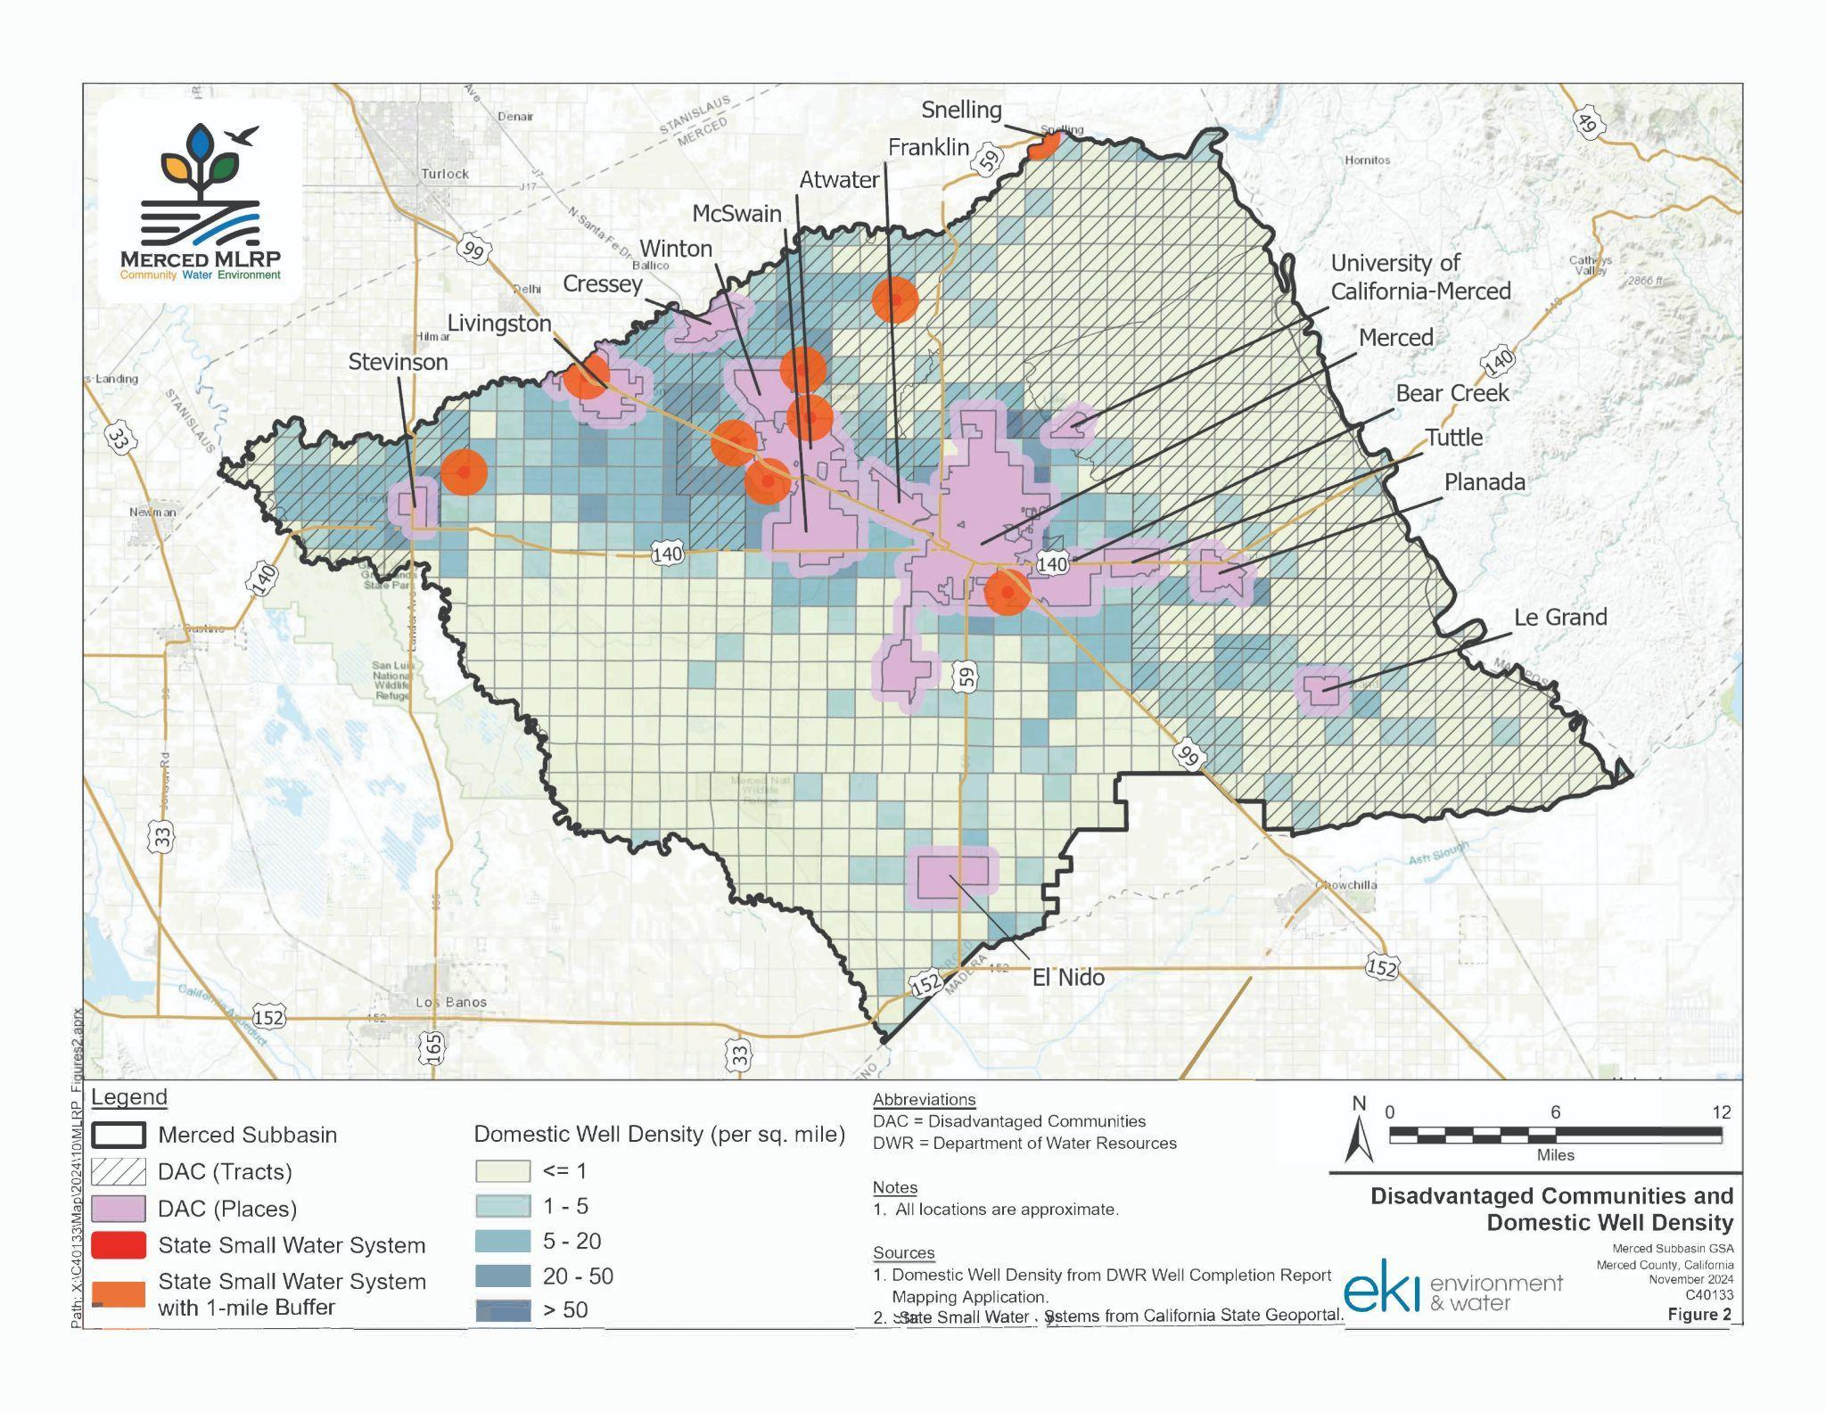

***Figure 1.******Disadvantaged Communities and Domestic Well Density*** *– This map highlights communities that the State of California recognizes as being disadvantaged (having an average annual median household income of less than 80% of the Statewide average). These census-designated disadvantaged communities are shown on this map with a 0.5-mile buffer (pink areas). The orange circles show water systems with less than 15 connections (State Small Water Systems) with a 1 mile buffer. The density of residential wells in rural areas are also shown to highlight where domestic well users are most likely to be impacted by groundwater extraction and drought conditions. Taken together, these data show where MLRP projects may have the greatest potential for benefits to disadvantaged communities and socially disadvantaged farmers and ranchers.*

## Funding Availability

A total of $1.2 million is available for a community benefit project or suite of projects that align with [DOC guidelines](https://www.conservation.ca.gov/dlrp/grant-programs/Documents/MLRP%20Round%202%20Guidelines_Amended%20April%202025.pdf#page=56) for meaningful benefits for disadvantaged communities. Up to $1.2 million per project may be awarded.

Note that this RFP is a solicitation for **Implementation Projects only**; a subsequent RFP will follow with funding for the design and permitting of projects that will not be implemented prior to the end of the grant period (March 30, 2027). The development funding RFP will be open to all project types and priorities, including but not limited to projects that provide meaningful disadvantaged community benefits.

Timeline Considerations:

All implementation projects (i.e. on-the-ground land repurposing projects) should plan to have project design and permitting completed by December 31, 2025, and **must be fully implemented prior to March 30, 2027**.[3]

## Application Deadline

Applications will be accepted on a rolling basis and projects will be reviewed for funding at the end of every month until a project or suite of projects are selected. Projects will be scored according to the Merced MLRP criteria and be considered for funding. Applicants are strongly encouraged to reach out to the Merced MLRP program team ahead of submitting an application to discuss project ideas and receive assistance creating a project that addresses the community benefit requirements under the MLRP. Please submit complete applications to [info@mercedmlrp.org](mailto:info@mercedmlrp.org).

## Project Eligibility

MLRP projects submitted in response to this solicitation must provide groundwater benefits by converting irrigated ag land to less water-intensive use(s) and must provide meaningful disadvantaged community benefits. Projects may provide additional benefits that align with the project selection criteria listed below. All stated public benefits derived from the use of MLRP funds must be provided for at least ten years. If you have questions about project types or eligibility, please contact [info@mercedmlrp.org](mailto:info@mercedmlrp.org).

## Eligible Applicants

Eligible Applicants include:Landowners; public agencies; nonprofit groups; local government agencies; California Native American Tribes that are either federally recognized or Tribes on the contact list maintained by the Native American Heritage Commission; Groundwater Sustainability Agencies; and Watermasters implementing an approved groundwater sustainability plan or approved alternative to a groundwater sustainability plan. Applicants should be locally-based or illustrate strong local partnerships in the Merced Subbasin.

*One application will be considered at a time per applicant for this RFP.*

## Project Prioritization

Project selections will be made based on a weighted criteria, which are summarized below and incorporate priorities identified in the CA Department of Conservation’s MLRP [Project Implementation Approval Packet](https://docs.google.com/document/d/10sRqdMvhVWVjRxP9i8UEmBGbWs8v7nIX/edit) at <https://tinyurl.com/mlrpguidelines>.

To be considered for funding, projects must address the Water Quality and Supply Criteria Category and the Disadvantaged Community Benefit Criteria Category. Projects that address additional Criteria Categories are likely to be more competitive than projects that do not.[4] Additional details on project selection criteria can be found starting on page 10 of the Project Application.

**Project Selection Criteria Overview:**

***Merced Water Quality and Supply (Priority Criteria)***- This RFP requires that projects improve groundwater supply, quality, and resilience and/or improve floodplain management and storage.

***Disadvantaged Community Benefits (Priority Criteria)***- This RFP requires that projects provide drinking water supply and security benefits for disadvantaged communities, improve economic and workforce benefits, and/or provide other benefits to disadvantaged communities (i.e. green space, recreation opportunities, improved air quality, educational opportunities, etc.).

***Feasibility and Cost-Effectiveness (Priority Criteria)*** - Projects must demonstrate implementation-readiness, be cost-effective, be feasible to implement, and have a feasible impact. Projects may also demonstrate the potential to replicate the project design.

***Regional Coordination (Priority Criteria)*** - Projects will receive additional priority by demonstrating local partner and community support, and/or incorporating participation from diverse local partners.

**Projects may receive additional points for addressing additional benefits outlined in the criteria below.**

***Agricultural and Economic Resiliency***- The program will prioritize projects that improve the sustainability of local agricultural economies by repurposing lands least viable for agriculture, shifting crop types or farming methods, and/or diversifying economic opportunities for the region.

***Regional Ecological Benefits*** - The program will prioritize projects that improve ecological outcomes through increased habitat connectivity, direct benefits to state and federal species of interest, increased resiliency of groundwater-dependent ecosystems, and/or other ecological benefits to the Merced Subbasin.

***Geographic Prioritization*** - The program will prioritize projects that are proximal to disadvantaged communities or their critical water infrastructure, and existing or developing water conservation projects and facilities. Additionally, projects will be prioritized that are situated in areas with severe subsidence and/or severe water depletion.

***Additional Considerations*** *-* Projects that provide an in-kind cost share or include match contributions may be granted additional consideration. Alternatively, projects that exhibit a critical financial need for execution of the project may also be granted additional consideration.

## Technical Assistance & Project Development Support

If you are interested in submitting a project application but need assistance with the development of your project idea and/or the application, please fill out [this form](https://docs.google.com/forms/d/1upo6jqGFRPuqBoaSkE00ogx6gAhhB0nnVf7i_v3IzdQ/edit) or contact [info@mercedmlrp.org](mailto:info@mercedmlrp.org) with any questions.

# 

# **Implementation Project Application for a Community Benefit Project**

Merced Subbasin Multibenefit Land Repurposing Program

*Publication Date: April 25, 2025*

*Application Deadline: Applications accepted on a rolling basis*

# 

# Application Checklist

*Submitted Application Package must include all of the following items:*

Completed Merced MLRP Application

Map of Project Site (if applicable)

Work Plan

Project Budget

Community Letters of Support and/or Proof of Community Engagement

Additional Letters of Support or Commitment (as applicable)

*For assistance with this application, please contact* [*info@mercedmlrp.org*](mailto:info@mercedmlrp.org)*.*

*Para ver este aviso en español, por favor visite* [*www.mercedmlrp.org*](http://www.mercedmlrp.org)*. Si necesita ayuda, por favor comuníquese con* [*info@mercedmlrp.org*](mailto:info@mercedmlrp.org)*.*

# Project Overview

Project name:

Organization or applicant name:

Organization type:

Primary applicant’s name and title:

Project partners (list all):

Phone:

E-mail address:

Mailing address:

Project location/Assessor Parcel Numbers (APN):

Landowner (if not the primary applicant):

Project Site Access (if applicant is not the landowner):

Anticipated start date: End date:

## Executive Summary

*Please provide a short one-paragraph summary of the proposed project below. Additional space to describe the project is provided throughout the application document.*

## 

## Project Type

*Please select the project type(s) below that best describe(s) the nature of your project.   
Select all that apply.*

Rewilding landscapes: Creation or restoration of habitat such as pollinator, wetland, upland, and riparian habitat.

Creation of multibenefit groundwater recharge areas.

Restoring floodplains.

Transition of irrigated land to dryland farming or non-irrigated rangeland.

Transition to less water-intensive crops, including native seed production.

Planting of cover crops or conservation cover.

Reestablishment of Tribal land uses and/or implementation of Tribal cultural practices.

Facilitation of renewable energy projects that have an overall net greenhouse gas reduction.

Creation of parks or community recreation areas.

Easement acquisitions, including conservation easement and flood easement acquisitions, to facilitate land repurposing and protect repurposed land uses.

Voluntary land transfers to Tribes or qualified public entities to facilitate land repurposing and protect repurposed land uses.

Other projects that meet the conservation and community-based objectives of the MLRP (please contact [info@mercedmlrp.org](mailto:info@mercedmlrp.org)).

Other. Please describe below:

## Project Longevity

*Please note the anticipated period of benefit provided by your project (eligible projects must provide at least 10 years of benefit beyond project implementation). Select one of the following:*

This project will provide resource benefits for _________ years following project implementation.

Project will provide benefits in perpetuity.

## Funding Summary

Total estimated project cost:

MLRP funding requested:

Match (if applicable):

## Project Description:

*Please describe the proposed project below (3 pages maximum).*

## Additional Project Information:

**Will the landowner give up any water allocation under the scope of the project proposed?**

Yes

No

*If yes, please describe the nature of the water supply forfeiture below:*

**Will the implementation of your project enable future recharge in the subbasin?**

Yes

No

*If yes, describe the mechanism and infrastructure available or needed for transporting water to the property and the applicable water rights/agreements as appropriate:*

**Is your project located on a solely groundwater-dependent property?**

Yes

No - there is access to surface water on the property.

Please describe further if necessary:

## Work Plan

Please provide a detailed work plan organized by Task. This plan should include all work to be completed by the applicant and any deliverables associated with that task. Please note that projects must be completed prior to March 30, 2027 and all project invoices must be submitted by December 31, 2026 for reimbursement. Please add additional Tasks as needed below. If selected, applicants may be asked to provide a more detailed Work Plan.

**Task 1**: [Enter Task Name]

**Description:**

**Deliverable(s)**: [Enter Text Here]

**Anticipated Completion Date**: [Enter Text Here]

**Task 2**: [Enter Task Name]

**Description:**

**Deliverable(s)**: [Enter Text Here]

**Anticipated Completion Date**: [Enter Text Here]

**Task 3**: [Enter Task Name]

**Description:**

**Deliverable(s)**: [Enter Text Here]

**Anticipated Completion Date**: [Enter Text Here]

## Project Budget

Please attach a task-based project budget with your submission that allocates project costs by the Tasks listed in the Work Plan described in the previous section. MSGSA may work with applicants subsequent to the application period to refine project budgets as necessary.

## Technical Assistance and Project Support

*It is anticipated that some projects may need technical assistance to proceed through project development and/or implementation. Depending on the nature of the project, technical assistance may be available through the MLRP program and its partners. Resources may be available to support projects via: planning, design, project management, administration, reporting, and habitat restoration.*

**Does your project require technical assistance?**

Yes

No

***If your project will require technical assistance or support, please describe the need below:***

## Environmental Review - CEQA Status

Projects are subject to the California Environmental Quality Act (CEQA). Please select a box below that best reflects your project, and provide a short description in the space provided.

**The proposed project (select one):**

|  |  |
| --- | --- |
| Is not a project under CEQA. Briefly specify why in the space below. |  |
| Is exempt under CEQA. Provide the CEQA exemption number and specify how the project meets the terms of the exemption in the space below. |  |
| Requires Neg Dec, MND, or EIR. Specify the lead CEQA agency (the agency preparing the document) and the (expected) completion date in the box below. |  |
| Unsure if this project requires CEQA compliance. Please contact [info@mercedmlrp.org](mailto:info@mercedmlrp.org) for assistance. |  |

# 

# Merced MLRP Project Selection Criteria

Project selections will be made based on the weighted criteria listed below, which incorporate priorities identified in the CA Department of Conservation’s MLRP [Project Implementation Approval Packet](https://docs.google.com/document/d/10sRqdMvhVWVjRxP9i8UEmBGbWs8v7nIX/edit) at <https://tinyurl.com/mlrpguidelines>. For each of the following sections, please select all elements that apply to your project and explain how your project will fulfill the selected criteria in a short explanation at the bottom of each page.

**To be considered for funding, projects must address at least one element in the Water Quality and Supply Category and the Disadvantaged Community Benefit Category. Projects that address additional Criteria Categories are likely to be more competitive than projects that do not.**

**Priority Criteria Categories**

* Merced Water Quality and Supply (25 Points)
* Disadvantaged Community Benefits (50 Points)
* Feasibility and Cost-Effectiveness (25 Points)
* Regional Coordination (10 Points)

**Additional Criteria**

* Agricultural and Economic Resiliency (5 Points)
* Regional Ecological Benefits (5 Points)
* Geographic Prioritization (5 Points)
* Additional Considerations (5 Points)

**Merced Water Quality and Supply (25 Points)**

*This RFP requires that projects improve water supply quantity, flexibility, quality, and resiliency and/or improve floodplain management and storage. Select all that apply. Projects may receive full points if they thoroughly address a single criterion, or multiple criteria within this section. Please see Appendix A for a map of Land Suitability for Groundwater Recharge.*

|  |  |
| --- | --- |
| **Criteria addressed by the project (select all that apply):** |  |
| ***Improved Water Supply Quantity, Flexibility, and Resiliency:*** Increases quantity of water in Merced Subbasin, flexibility in options for water usage including reduced-usage approaches, reduction of groundwater use, recharge of groundwater with surface water, all of which result in an improvement of basin-wide groundwater supply. |  |
| ***Water Quality Benefits:***Provides improvement in water quality that can be measured and demonstrated. |  |
| ***Floodplain Management and Groundwater Storage Benefits:*** Provides management strategies and mechanisms for floodplain management, increases groundwater recharge. |  |
| ***"Measurability/Observability" of Benefits:***Provides water benefits which can be measured or noted consistently, and are able to be maintained for a minimum of 10 years beyond project implementation (CA Department of Conservation implementation requirement). |  |

**Describe how the project addresses the selected Criteria (1 page maximum):**

**Disadvantaged Community Benefits (50 Points)**

*This RFP requires that projects provide drinking water supply and security benefits for disadvantaged communities, provides economic and workforce benefits, and/or provide other benefits to disadvantaged communities (i.e. green space, recreation opportunities, improved air quality, educational opportunities, etc.). Select all that apply. Projects may receive full points if they thoroughly address a single criterion, or multiple criteria within this section. Please see Appendix B for a map of Disadvantaged Communities and Domestic Well Density and more information about how disadvantaged communities are identified.*

|  |  |
| --- | --- |
| **Criteria addressed by the project (select all that apply):** |  |
| ***Drinking Water Supply and Security Benefits and/or Water Quality Benefits for Disadvantaged Communities:***Improved access to safe drinking water; improved water security for disadvantaged communities; improved quality of water at recreational or public access sites in disadvantaged communities. |  |
| ***Economic and Workforce Benefits:***Provides economic and workforce opportunities for members of disadvantaged communities, improves access to support services, and/or mitigation of job displacement. |  |
| ***Other Disadvantaged Community Benefits:*** Increased community benefits such as: increased green spaces and/or recreational areas, improved air quality, improved soil quality, increased food security, reduced pesticide load or frequency of use, reduced flood risk, and educational opportunities. |  |
| ***Tribal Benefits:***Reestablishes stewardship of tribal resources that incorporates reduction of water use, improves tribal access to grow or forage native plants used in traditional cultural practices, provides resource availability or security, or provides another benefit to a tribe or band (applicant must be a tribe or band or demonstrate a substantive partnership with a tribe to select this criterion). |  |

**Describe how the project addresses the selected Criteria (1 page maximum):**

**Feasibility and Cost-Effectiveness (25 Points)**

*Projects must demonstrate implementation-readiness, be cost-effective, be feasible to implement, and have a feasible impact. Projects may also demonstrate the potential to replicate the project design.*

|  |  |
| --- | --- |
| **Criteria addressed by the project (select all that apply):** |  |
| ***Project Readiness:*** Project can be implemented in the near term (approximately 2 years). |  |
| ***Cost-Effectiveness:*** Project budget covers all aspects of the project and demonstrates an efficient use of funds. |  |
| ***Feasibility of Implementation:***Project can be feasibly implemented with available resources and given external constraints. |  |
| ***Feasibility of Impact:*** Anticipated project benefits can feasibly be achieved based on thorough delivery of project as designed. |  |
| ***Opportunity for Replication:***Project represents a potentially transferable model that could be replicated. |  |
| ***Applicant and Partner(s) Fiscal and Administrative Capacity:*** Project partners demonstrate fiscal and administrative capacity to complete project activities and oversee the project through to completion. |  |

**Describe how the project addresses the selected Criteria (½ page maximum):**

**Regional Coordination (10 Points)**

*Projects will receive additional priority by demonstrating local partner and community support, and/or incorporating participation from diverse local partners. If an applicant would like assistance in connecting or coordinating with local partners and community members, please contact the Merced MLRP program at* [*info@mercedmlrp.org*](mailto:info@mercedmlrp.org)*, or call (209) 202-3536; or contact MSGSA or MLRP partners directly.*

|  |  |
| --- | --- |
| **Criteria addressed by the project (select all that apply):** |  |
| ***Partner and Community Support:***Project incorporates participation from local partners and/or has letter(s) of support from local partners or communities. |  |
| ***Community Involvement:*** Local communities or community members endorse the project, provided the project idea, and/or co-created the project. |  |

**Describe how the project addresses the selected Criteria (½ page maximum):**

**Agricultural and Economic Resiliency (5 Points)**

*The Merced MLRP will prioritize projects that improve the sustainability of local agricultural economies by repurposing lands least viable for agriculture, shifting crop types or farming methods, and/or diversifying economic opportunities for the region. Select all that apply. Projects may receive full points if they thoroughly address a single criterion, or multiple criteria within this section. Please see Appendix C for a map of Irrigated Lands and Areas of Groundwater Decline.*

|  |  |
| --- | --- |
| **Criteria addressed by the project (select all that apply):** |  |
| ***Supports Sustainability of Local Agriculture:*** Supports sustainability of agriculture by targeting the least productive farmland for land repurposing, shifting crop types, adopting drought-resilient growing methods, or other practices that improve soil health. |  |
| ***Sustains Agricultural Economies:***Minimizes agricultural job displacement or provides other economic benefits including increased pay, benefits, job security, and/or working conditions for farmworkers. |  |
| ***Diversifies Economic Opportunities:***Diversifies economic opportunities by providing training or job opportunities in land-based economies. |  |

**Describe how the project addresses the selected Criteria (½ page maximum):**

**Regional Ecological Benefits (5 Points)**

*The Merced MLRP will prioritize projects that improve ecological outcomes through increased habitat connectivity, direct benefits to state and federal species of interest, increased resiliency of groundwater-dependent ecosystems, and/or other ecological benefits to the Merced Subbasin. Select all that apply. Projects may receive full points if they thoroughly address a single criterion, or multiple criteria within this section.*

|  |  |
| --- | --- |
| **Criteria addressed by the project (select all that apply):** |  |
| ***Habitat Connectivity:*** Increased possibility for connectivity of habitat sites that enable wildlife to move across the landscape. |  |
| ***Species of Interest:*** Restoration or conservation of habitat suitable for wildlife such as endangered species/federally listed species, species of special concern, or other keystone species in the ecosystem on-site. |  |
| ***Groundwater Dependent Ecosystem Benefits:***Ecosystem benefits such as soil health, support of native vegetation, support of species diversity, and other benefits that are supported by increased groundwater availability. |  |
| ***Other Ecological Benefits:***Other benefits not quantified above, including but not limited to: increasing soil stability, soil desalination, increasing or providing native animal species overwintering/breeding/forage sites. |  |

**Describe how the project addresses the selected Criteria (½ page maximum):**

**Geographic Prioritization (5 Points)**

*This RFP will prioritize projects that are proximal to disadvantaged communities or their critical water infrastructure and existing or developing water conservation projects and facilities (as appropriate for the project’s proposed benefits). Additionally, projects will be prioritized that are situated in areas with severe subsidence and/or severe water depletion. Select all that apply. Projects may receive full points if they thoroughly address a single criterion, or multiple criteria within this section. Please see Appendices for relevant maps.*

|  |  |
| --- | --- |
| **Criteria addressed by the project (select all that apply):** |  |
| ***Proximity to Disadvantaged Communities:***Proximity of project to disadvantaged communities that stand to benefit from the project, and/or their critical water infrastructure such as well fields. |  |
| ***Connectivity to Existing or Prospective Projects and Relevant Facilities:*** Provides connectivity to existing or prospective projects or facilities that provide a connectivity benefit for infrastructure such as water conservation, recharge, storage, canals, conveyances, flood mitigation, etc. |  |
| ***Alignment with Projected Overdraft Regions, or Low Sustainability/Low Productivity lands:***Proximity of project to projected groundwater overdraft regions and/or location of project in a solely groundwater-dependent region. |  |

**Describe how the project addresses the selected Criteria (½ page maximum):**

**Additional Criteria and Considerations (5 Points)**

*Projects that provide an in-kind cost share or include match contributions may be granted additional consideration. Alternatively, projects that exhibit a critical financial need for execution of the project may also be granted additional consideration. Additional consideration may also be given to small or disadvantaged growers or other distinguishing factors not listed in the criteria above.*

**Describe any match contributions, critical financial needs, or benefits provided to small and/or disadvantaged growers that should be considered. Additionally, please describe any additional project benefit(s) not captured elsewhere in this application (½ page maximum):**

# 

# 

# Appendices

**Appendix A - Land Suitability for Groundwater Recharge**

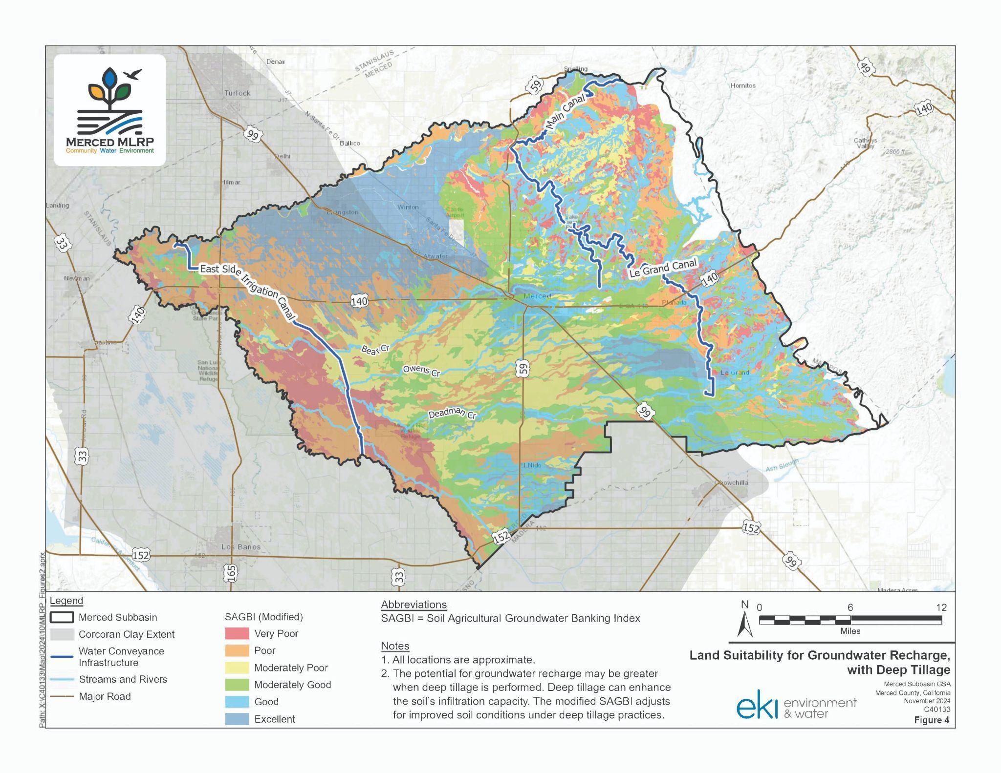

**Land Suitability for Groundwater Recharge** – This map depicts groundwater recharge capacity based on a modified version of the UC Davis SAGBI study, which assumes that soils in areas historically cropped with orchards or vine crops have been plowed to 6 feet deep to destroy restrictive soil layers that inhibit root growth. Deep tillage not only allows for deeper root growth but also facilitates rapid infiltration of water past the topsoil into lower soil horizons and ultimately improves recharge suitability.

**Appendix B - Disadvantaged Communities and Domestic Well Density**



**Disadvantaged Communities and Domestic Well Density** – This map highlights communities that the State of California recognizes as being disadvantaged (having an average annual median household income of less than 80% of the Statewide average). These census-designated disadvantaged communities are shown on this map with a 0.5-mile buffer (pink areas). The orange circles show water systems with less than 15 connections (State Small Water Systems) with a 1 mile buffer. The density of residential wells in rural areas are also shown to highlight where domestic well users are most likely to be impacted by groundwater extraction and drought conditions. Taken together, these data show where MLRP projects may have the greatest potential for benefits to disadvantaged communities and socially disadvantaged farmers and ranchers.

**Appendix C - Irrigated Lands and Areas of Groundwater Decline**

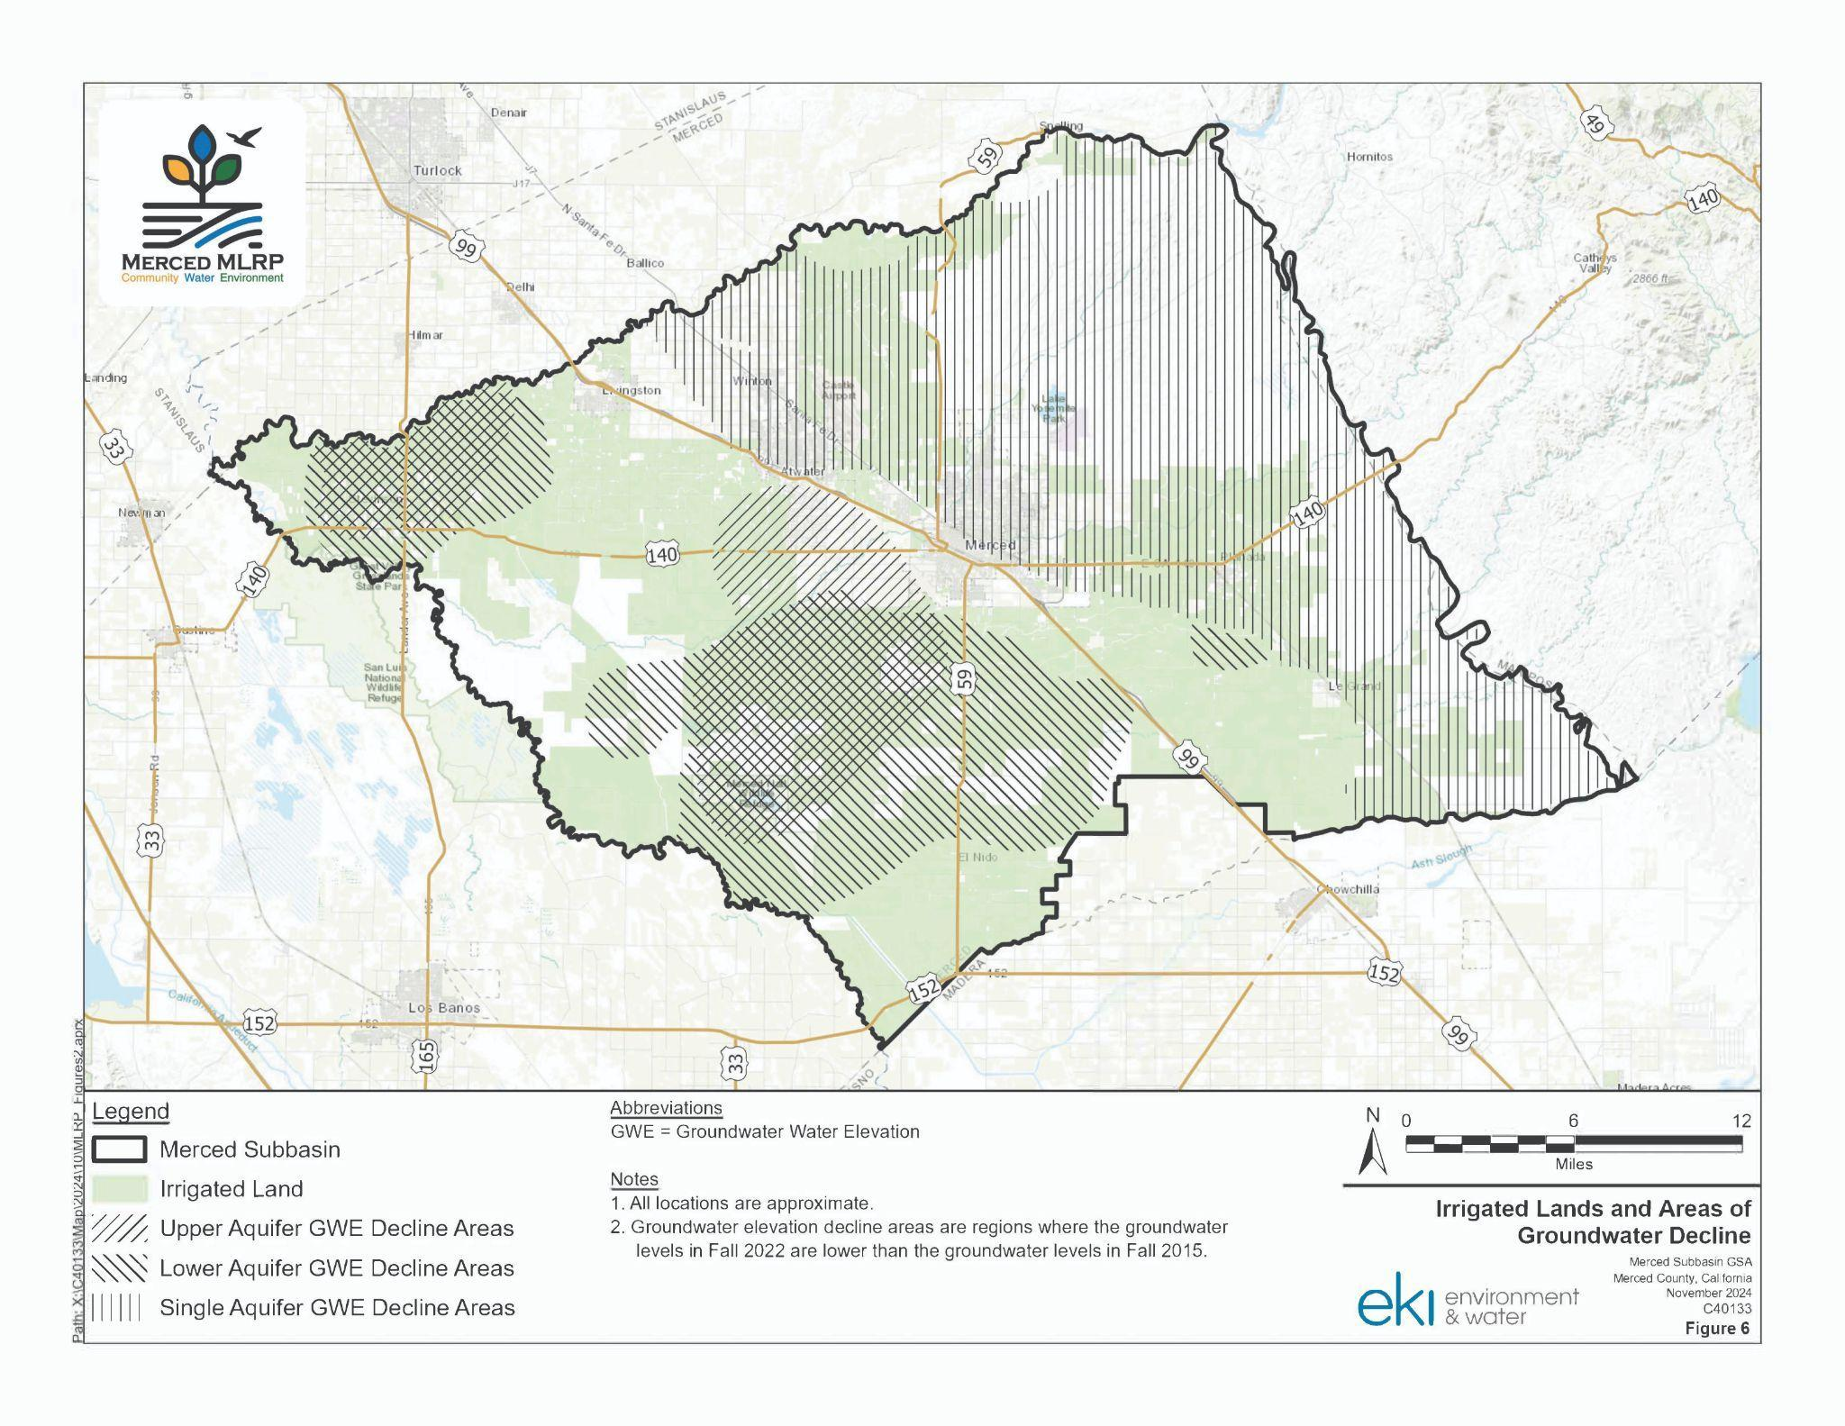

**Irrigated Lands and Areas of Groundwater Decline –** This map shows areas within the Merced Subbasin that are currently or have recently been used for the production of irrigated crops. The relationship between groundwater extraction and availability is highlighted by depictions of areas where aquifers have declined in upper, lower, and single aquifer systems.

1. *For the definition of meaningful community benefits, please refer to the California Department of Conservation’s* [*revised guidelines*](https://www.conservation.ca.gov/dlrp/grant-programs/Documents/MLRP%20Round%202%20Guidelines_Amended%20April%202025.pdf#page=56)*, adopted on April 21, 2025.* 
2. Hanak, Ellen & Escriva-Bou, Alvar & Gray, Brian & Green, Sarge & Harter, Thomas & Jezdimirovic, Jelena & Lund, Jay & Azuara, Josué & Moyle, Peter & Seavy, Nathaniel. (2019). Water and the Future of the San Joaquin Valley. 10.13140/RG.2.2.24360.83208.
3. *All project invoices must be submitted by December 31, 2026 for reimbursement, such that all program funds are expended by the end of the grant term.*
4. *If necessary, additional criteria may be adopted by the Merced MLRP to better distinguish similar projects.*